Investment Summary

Grassroot Peacebuilders
www.GPeacebuilders.com



Fundraising Information:
Raising: $50k investment in Series A Preferred Stock
Close Month: 04/2023

Primary Contact Information:
Christopher Andrade
Founder & CEO
candrad5@jhu.edu

Business
Grassroot Peacebuilders is a social venture created to help aspiring entrepreneurs launch social impact organizations through an online Incubator Program.

Problem
With violent conflict and extreme poverty rising, the world desperately needs affordable wealth creation and conflict resolution education. Globally, “violent demonstrations have increased by 49% since 2008” (Global Peace Index 2022 - World, 2022), and over 605 million people are now living in extreme poverty (World Poverty Clock, 2023). Additionally, millions of workers lost their jobs due to the COVID-19 pandemic (WEF, 2021), and the rise of artificial intelligence may make up to 375 million jobs obsolete over the next decade (Kolmar, 2023).

Solution
Social entrepreneurship is how individuals, startups, and entrepreneurs develop and fund solutions that directly address social causes while providing a path for job security, poverty alleviation, financial independence, and positive peace. The Peacebuilder Academy is an online incubator program that uses social entrepreneurship to address the United Nations’ 17 Sustainable Development Goals (SDGs), and the “2030 Agenda for Sustainable Development [which] provides a shared blueprint for peace and prosperity for people and the planet, now and into the future” (United Nations, n.d.). The program provides the following:
- Project Management and Social Business Education
- Teaches integrative (interest-based) negotiations as a form of conflict resolution
- Templates, resources, tools, coaching, and mentorship
- Teaches meditation and self-mastery to guide aspiring peacebuilders toward inner peace

Revenue Model
Our revenue model is based on a hybrid freemium and subscription business model. Our largest revenue stream will be from recurring monthly subscriptions from aspiring entrepreneurs, peacebuilders, career transitioners, and retirees. Our average customer is $600 in recurring revenue per year. We project $120K total revenue per year. Subscribers can pay for an annual plan at a discounted price or pay on a monthly basis. Below is the breakup of our revenue projections:
- 65% of the total will be from the Peacebuilder Academy’s user subscriptions. This year-long program provides unlimited access to training, live testimonials from successful social entrepreneurs, templates, resources, coaching, and mentorship.
- 20% of the total revenue is from the specialized Meditation and Motivation programs. The subscription cost is received and recorded as revenue.
- 15% of the total revenue will be received from the college/university program subscription on a semester basis. Students are required to sign up for the ‘Promoting Social Entrepreneurship program’ as a part of their coursework. The subscription cost is recorded as revenue.
*Note: Annual technology fees are an estimated $2K/year.

Total Addressable Market (TAM):
We estimate the global market as 220 million people representing a $4.4 billion (220M*$20/mo) opportunity. In the U.S. we project a service obtainable market (SOM) as $1 to $2.6 million per year as follows:

 | Low | High
Potential customers | 1000 | 3600
Ave. revenue/customer/year | $600 | $1000
U.S. TAM per year ($ millions) | $0.6 | $3.6

Our estimated range of potential customers was based on the Massive Open Online Course industry overview by Mordor Intelligence and E-Learning Statistics by e-student.org.

Select Customers
- College/Universities: Johns Hopkins University, American University, George Mason University, University of Maryland
- Youth Organizations: Scouts, Peace First, YMCA, YWCA, Boys & Girls Clubs
- Other: Aspiring entrepreneurs and peacebuilders, career transitioners, retirees, and investors

Competitors
The primary competitors for our social venture are well-established online learning platforms like Udemy, Coursera, and Skillshare that offer affordable, high-quality, and a wide range of courses on various subjects. Grassroot Peacebuilders also competes with the following organizations:
- Competitor 1 (netimpact.org) – Net Impact offers various programs to empower individuals to use their skills to create positive social and environmental change. Our solution is better because our courses are taught by subject matter experts that address the UN's 17 Sustainable Development Goals (SDGs).
- Competitor 2 (peacefirst.org) – Peace First offers workshops and training programs to support young people in creating innovative solutions to social problems. Our solution is better because our program couches youth to make money while saving the world.

CEO Background

Christopher Andrade is a certified Project Management Professional with over 10 years of experience and a 2024 MBA/MA in Government dual-degree candidate at Johns Hopkins University. He has worked and volunteered with the DoD, NGOs, former foster youth, and peace organizations. In his free time, he enjoys scuba diving, traveling, and podcasts.
- 2012 to 2016 - Army Infantry Officer- selected, trained, and managed two 30-man teams (i.e., platoons) and up to $14 million in equipment in Bagram, Afghanistan (2014)
- 2016 to 2019 - Military Intelligence Officer- Senior Intelligence Officer/Regional Operations Analyst for US Forces Korea (USFK), Internal Auditing Division Director with 116 sub-departments
- 2019 to 2023 - Founding Grassroot Peacebuilders (bootstrapping), JHU Grad student
*See Appendix A for bios of other team members.

Income Summary
With a $500 thousand seed round by 04/2023, management is projecting to be cash flow positive in Q4 2024 (see Appendix B for 6-year projection):
(in $000's) | 2023 | 2024 | 2025
Annual Users | 180 | 1200 | 3600
Revenue (GAAP) | $9.0 | $60 | $180
Gross Margin | 77% | 96.6% | 98.9%
EBITDA | ($45.8) | ($3.2) | $121.6

Balance Sheet Summary
As of 03/11/23: $28,700.00; $28,700.00 cash available (Founder savings); $0 debt outstanding

Use of funds
We are targeting a $50 thousand Series A round by 04/2023, and the use of funds is as follows:
- $10k – to hire one part-time developer to finish online curriculum in the next twelve months
- $10k – to hire one part-time Digital Marketing Specialist
- $2k – for legal and accounting fees
- $8k – impact fund to accelerate promising social businesses
- $20k – for growth initiatives, marketing, operations, and working capital.
With this investment round, we will be able to complete product development and a successful launch with an expected cash flow break even by 12/2024.

Equity Ownership
Currently, the CEO/Founder has 80% equity ownership. The remaining 20% is accounted for in equity compensation to the senior-level management team (COO, CFO, CMO, CTO) and varies by restricted stock and employee performance.

Investment History
Total of $14,800.00 invested capital as follows:
06/2022: $14.8 thousand cash was invested from Founder’s personal bank account (bootstrap)
Management team investment:
- CEO has invested $14.8 thousand from personal funds with $28.7 thousand remaining.

HQ and Employees
Headquarters in Washington, DC:
- 3 full-time employees: CEO, COO, CFO
- 2 contractors/1099: digital marketing, CRM, product development
- Contract basis: Guest coaches, speakers, instructors, educators

Appendix A: Our Team


Shweta Deshpande
Position: Chief Financial Officer (CFO) at Grassroot Peacebuilders.
Shweta works as a Lead financial engineer at a financial firm. She has more than 13 years of experience in Fair Value Pricing of Asset portfolios. At Grassroot Peacebuilders, she has worked as a CFO for the past 2 years.
She also works as the volunteering activity coordinator for a non-profit organization and aspires to bring a positive change in the community.


Quyên Vuong
Position: Chief Operating Officer (COO) at Grassroot Peacebuilders.
Quyên has over 7 years of experience in healthcare management, 6 years of building a small business, and she is an expert in developing new programs and initiatives to support an organization's mission. She is an active member of the non-profit community and serves as a small business consultant in Silicon Valley. In her free time, she enjoys cooking and discovering stories behind new dishes.


Daniel Zellis
Position: Chief Technology Officer (CTO) at Grassroot Peacebuilders.
While Daniel has a limited tech background, he is overzealous to learn. At 22 he is working on his bachelor's and master's simultaneously. He hopes to bring a young perspective to the team. In addition, Daniel likes to read and volunteer to fundraise for his school in his free time.

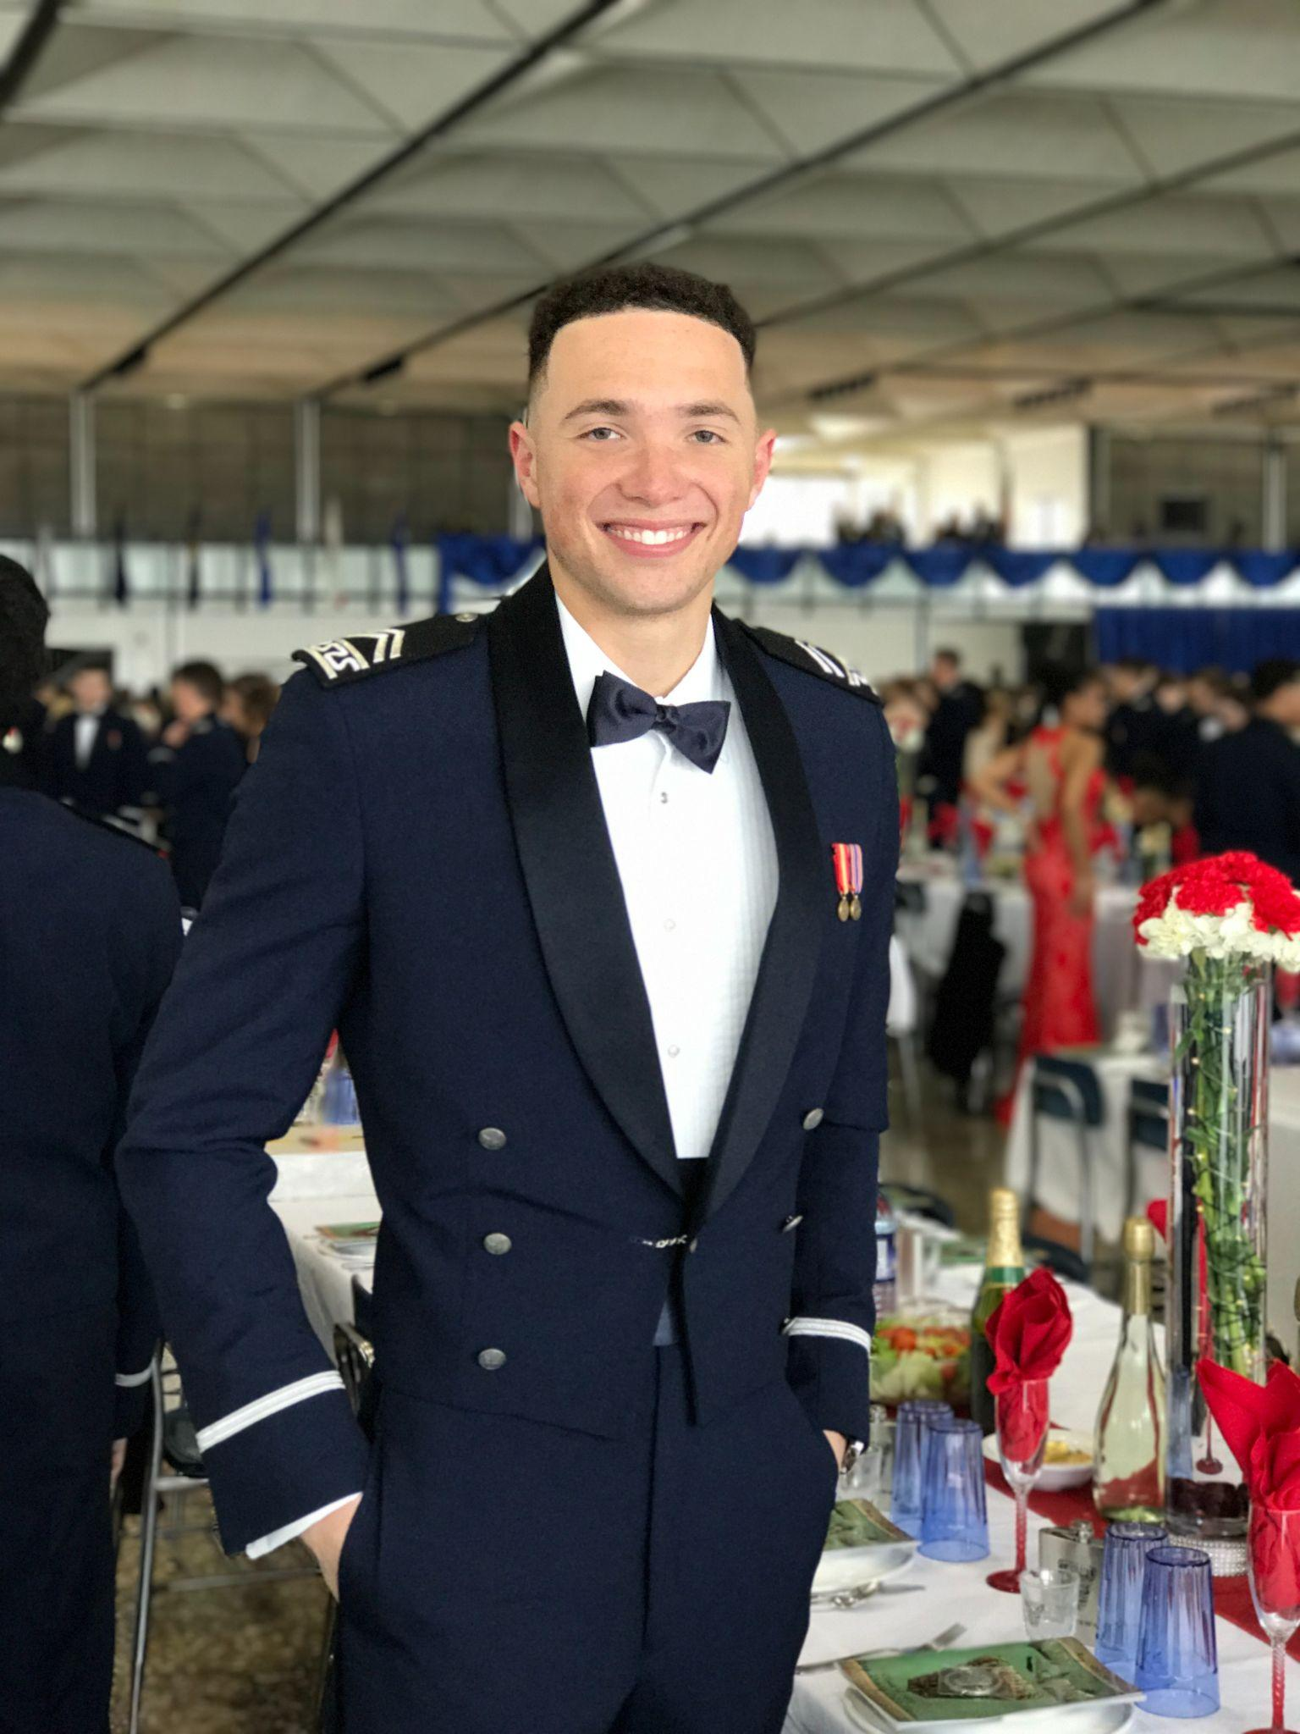
Jake McGraw
Position: Chief Marketing Officer (CMO) at Grassroot Peacebuilders.
Jake has served as the brand management and strategic communications lead for Grassroot Peacebuilders for over two years. After graduating from the United States Air Force Academy with a B.S. in Business Management. he served as an Acquisitions Officer overseeing multiple high-level Department of Defense programs at the Pentagon. Jake enjoys mentoring younger military members, crossfit, and reading all things related to value investing.

Appendix B- Projections

6-Year Projections:

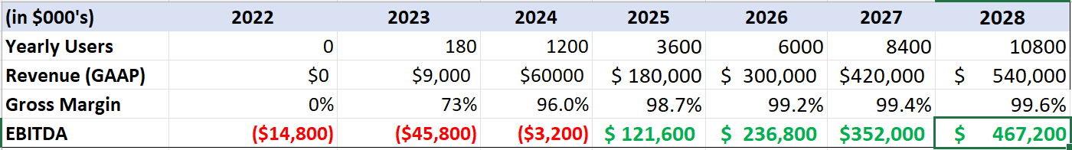

Assumptions & Calculations (See Attached Excel Sheet For Formulas)

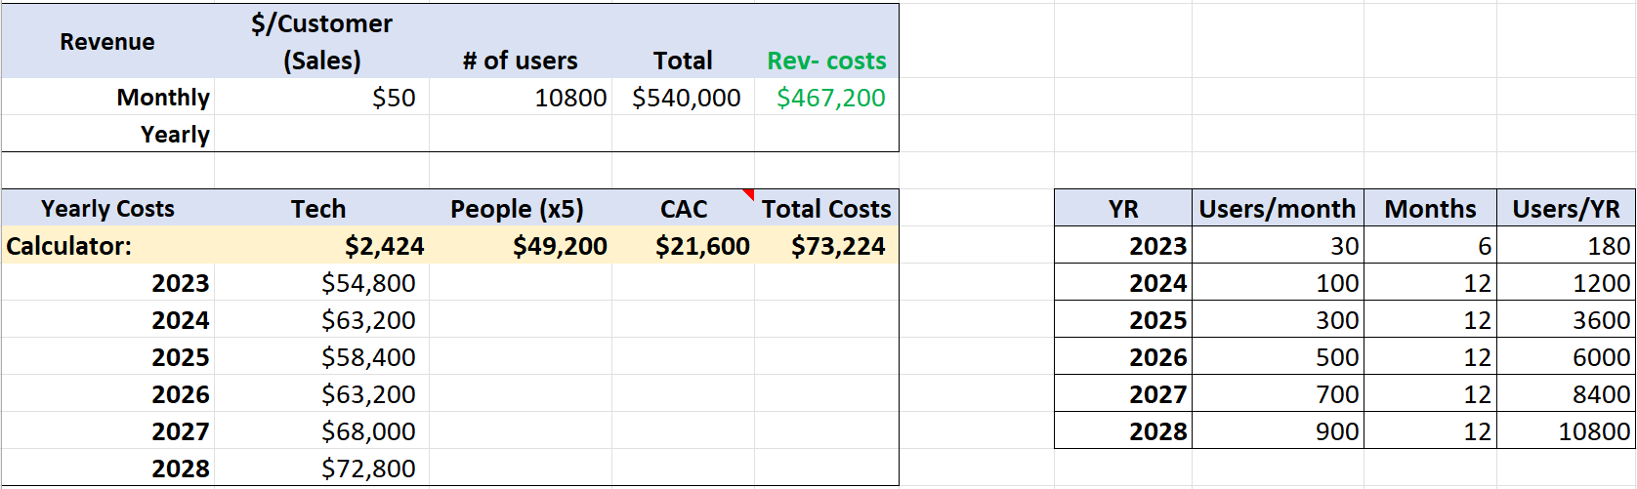

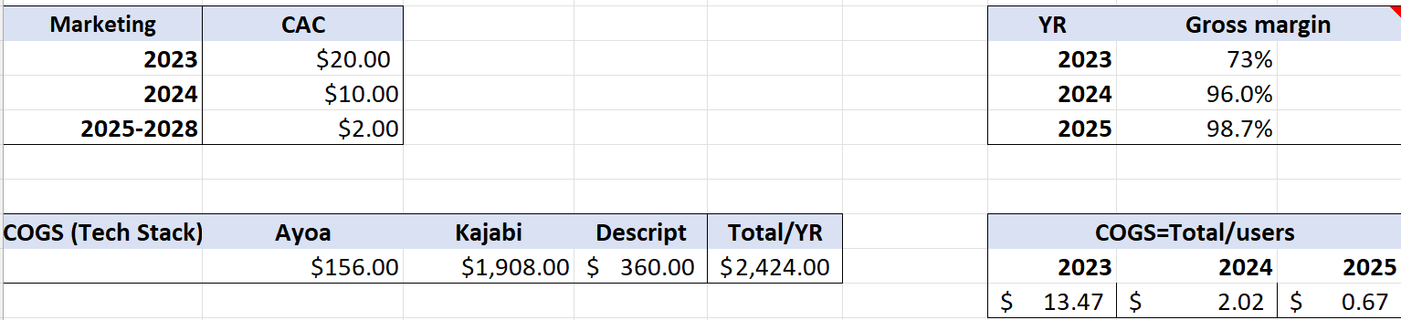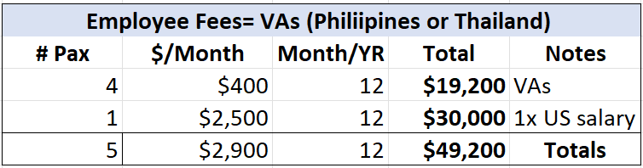

References

COVID-19 has caused a huge amount of lost working hours. (2021, February 4). World Economic Forum. Retrieved March 10, 2023, from https://www.weforum.org/agenda/2021/02/covid-employment-global-job-loss/

Global Peace Index 2022 - World. (2022, June 15). ReliefWeb. Retrieved March 10, 2023, from https://reliefweb.int/report/world/global-peace-index-2022

Kolmar. (2023, February 7). 23+ Artificial Intelligence And Job Loss Statistics [2023]: How Job Automation Impacts the Workforce – Zippia. Zippia. Retrieved March 10, 2023, from https://www.zippia.com/advice/ai-job-loss-statistics/

Massive Open Online Course Market Analysis - Industry Report - Trends, Size & Share. (n.d.). Mordor Intelligence. Retrieved March 10, 2023, from https://www.mordorintelligence.com/industry-reports/massive-open-online-course-mooc-market

Peace First – Youth led peacemaking projects. (n.d.). Peace First. Retrieved March 10, 2023, from https://www.peacefirst.org/

Tamm, S. (2023, January 5). 100 Essential E-Learning Statistics for 2022. E-Student. Retrieved March 10, 2023, from https://e-student.org/e-learning-statistics/

THE 17 GOALS | Sustainable Development. (n.d.). United Nations. Retrieved March 10, 2023, from https://sdgs.un.org/goals

Why Social Entrepreneurship Matters | Net Impact. (n.d.). Net Impact. Retrieved March 10, 2023, from https://netimpact.org/blog/why-social-entrepreneurship-matters

World Poverty Clock. (2023). World Data Lab. Retrieved March 10, 2023, from https://worldpoverty.io/map

